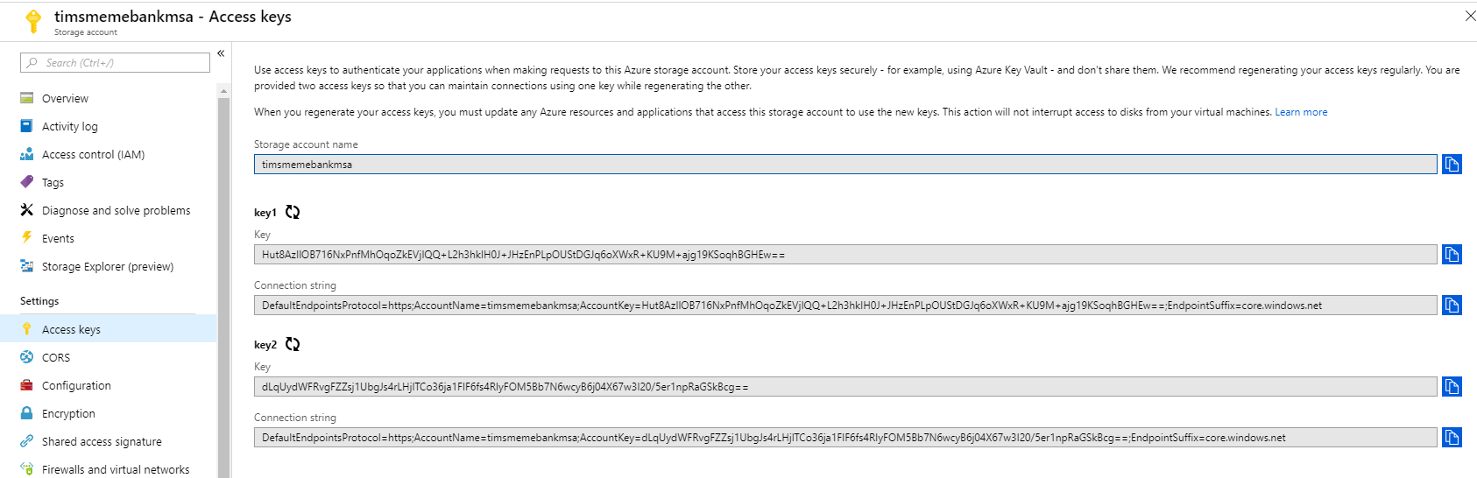

Storage account name: timsmemebankmsa

**https://timsmemebank.azurewebsites.net**

Key1: Hut8AzIlOB716NxPnfMhOqoZkEVjIQQ+L2h3hkIH0J+JHzEnPLpOUStDGJq6oXWxR+KU9M+ajg19KSoqhBGHEw==

Connection string: DefaultEndpointsProtocol=https;AccountName=timsmemebankmsa;AccountKey=Hut8AzIlOB716NxPnfMhOqoZkEVjIQQ+L2h3hkIH0J+JHzEnPLpOUStDGJq6oXWxR+KU9M+ajg19KSoqhBGHEw==;EndpointSuffix=core.windows.net

Key2: dLqUydWFRvgFZZsj1UbgJs4rLHjlTCo36ja1FIF6fs4RIyFOM5Bb7N6wcyB6j04X67w3I20/5er1npRaGSkBcg==

Connection String: DefaultEndpointsProtocol=https;AccountName=timsmemebankmsa;AccountKey=dLqUydWFRvgFZZsj1UbgJs4rLHjlTCo36ja1FIF6fs4RIyFOM5Bb7N6wcyB6j04X67w3I20/5er1npRaGSkBcg==;EndpointSuffix=core.windows.net

. .

Storage account name : memebank1001

Key1 = Jxo2PdQi71sQdKsGCwNK9xNwWsCBcSkHLdmsx1KNdILrMxOwXZ2GFppOVJYsTvGybZbTNYHmv+rtxs+2mOay4g==

Connection string = DefaultEndpointsProtocol=https;AccountName=memebank1001;AccountKey=Jxo2PdQi71sQdKsGCwNK9xNwWsCBcSkHLdmsx1KNdILrMxOwXZ2GFppOVJYsTvGybZbTNYHmv+rtxs+2mOay4g==;EndpointSuffix=core.windows.net

Key2 = 2TjBbY6PSjUaGg1w/yKT7J+xi1+pLlfs6TPo/RTfG0urm9hMCpi9WG2Jz+GKUigjs52cY1I32xsaq+8gWivVnQ==

Connection string = DefaultEndpointsProtocol=https;AccountName=memebank1001;AccountKey=2TjBbY6PSjUaGg1w/yKT7J+xi1+pLlfs6TPo/RTfG0urm9hMCpi9WG2Jz+GKUigjs52cY1I32xsaq+8gWivVnQ==;EndpointSuffix=core.windows.net